**Gate Way & Pace in Citrix**

* **CITRIX**

Login to Citrix - [NetScaler Gateway](https://employees.changehealthcare.com/logon/LogonPoint/tmindex.html)

* login username and password

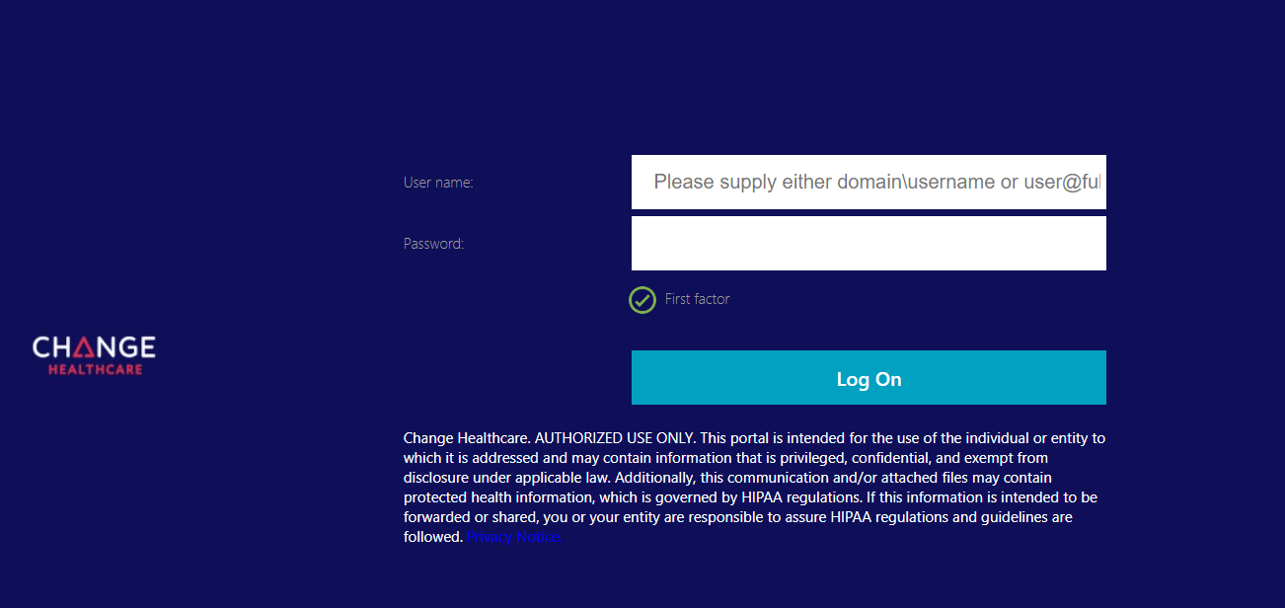

* 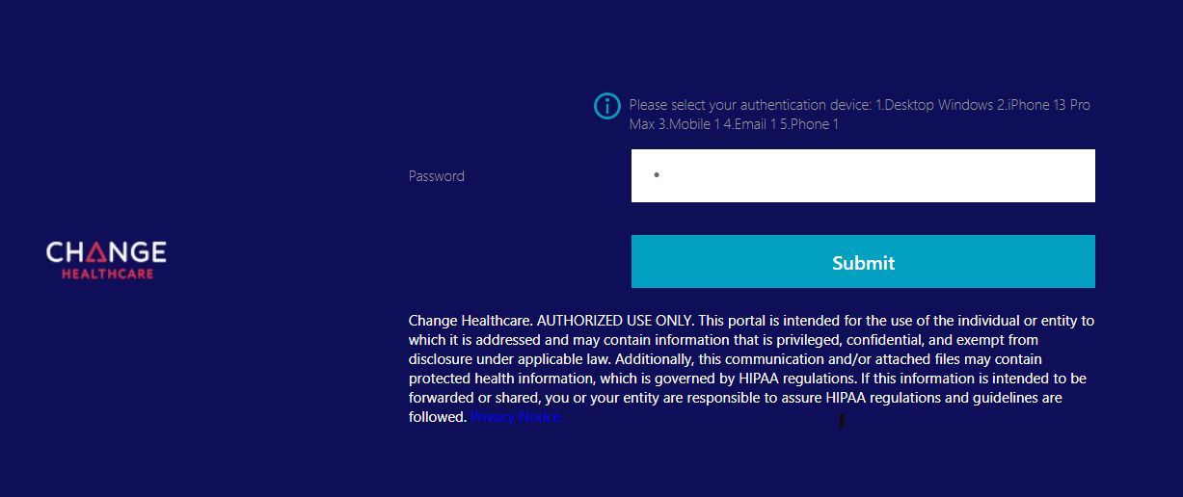authentication device – put or use the numbers for options you want to choose.
* 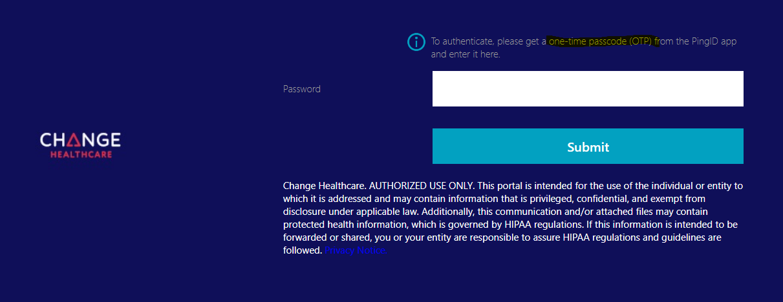input here the OTP and then submit
* you will be routed here, then click that one drive and chrome logo in yellow highlights

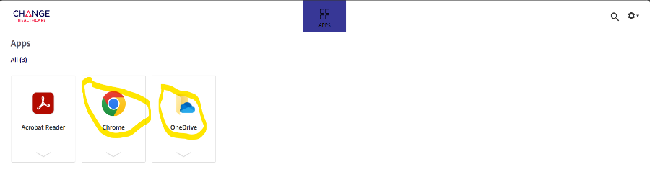

* now go to downloads and open both files, follow the highlighted instructions below

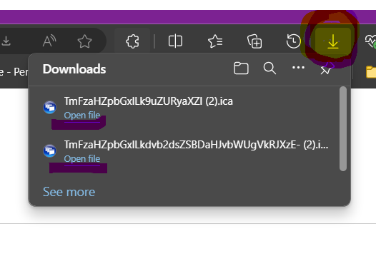

* once you open the one drive file this one drive below will pop up and we need to sync this to our personal one drive

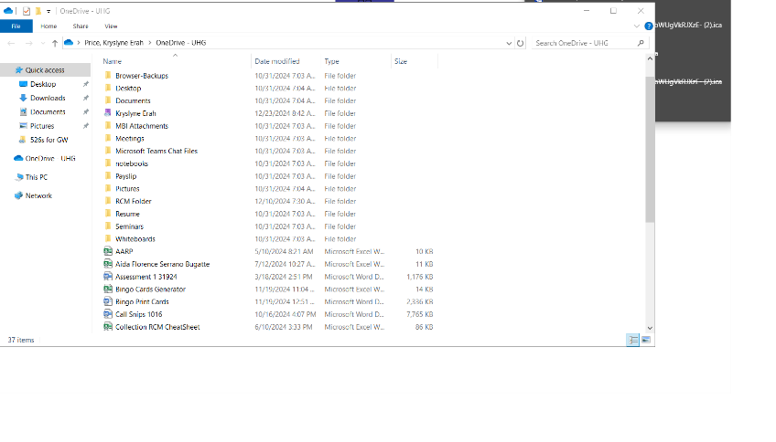

* 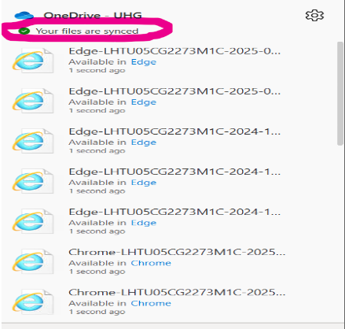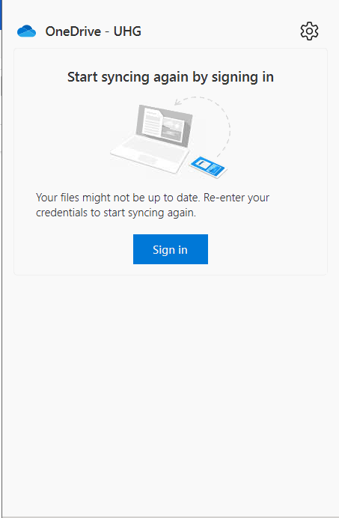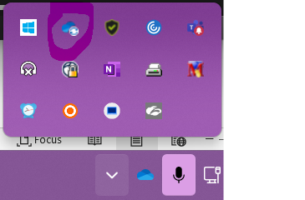To sync it we need to login in our personal one drive, follow 1st snip bellow and login in your personal account. Once you are signed in this will automatically be synced see third snip.

1st 2nd 3rd

* once you open the Chrome file in download it will be routed to this Google Chrome Site, this Google application is having a strict security policy that disables the copy and paste feature, so we need to manually type everything.

* **PACE**

Using the Citrix Chrome site login PACE

1. Search patient by PACE number in PACE search field found on the list of applications to submit. Then, *if the application is EMA*, search all account numbers linked to the application you are working in the OneDrive folder for 526s.
2. Follow snip bellow click the down arrow for Additional Information and find Username and Password. Follow snip bellow.

*If there is no username or password listed- try to use Pace ID with CHI ex: (CHI9644949) and from the password is Pace ID with CHi sa end ex: (9644949Chi). If it won’t come up, then notate in excel.

* **GATEWAY**

1. Go to web address <https://gateway.ga.gov/access/> and click on Manage My Account/Login

4.Enter the Username and Password from PACE into the appropriate fields and click Login Now

5. Click “I Accept”

6. Scroll down to Status of Application and click Select here to continue application.

*If the page that loads does not show ‘Status of Application’ at the bottom, go to Quick tips #6.

1. A screenshot of a computer screen

   Description automatically generatedThe next page will show “Signing Your Application” at the top – scroll to the bottom of the page

1. A screenshot of a computer

   Description automatically generatedAt the bottom of the page, click the ‘Submit’ button to the far right

1. A screenshot of a computer

   Description automatically generated Click ‘Next’ at the bottom of the next page. It will reload, and you will click ‘Next’ again.

1. A screenshot of a computer

   Description automatically generatedNext, reference the application type in PACE. If the application type includes ‘EMA (see snip bellow) go to step 11. If not, follow steps 16-19.
2. If the application type is EMA, click Upload Documents

1. Select ‘Medical Bills/Documents and scroll down to Step 2.

1. In the Step 2 section, select ‘Application Selection’, check the box for ‘Medical Assistance’, and in the drop down select the first name listed. Then, click ‘Attach’

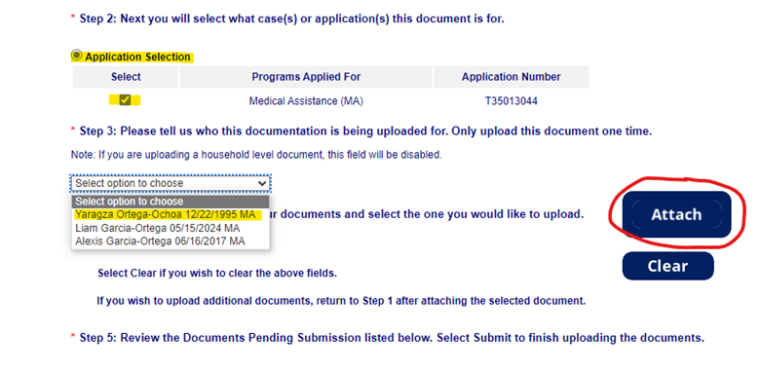

14. After you click ‘Attach’, a window will open to select from a file location. You will select the file folder named ‘526s for GW’, then search for the account number(s) linked to the application you are submitting. Then click ‘Open’.

*\*Note: The account number will be included on the assignment spreadsheet, and can also be found in PACE – see step 2 screen shot.*

*\*\*note: You must upload a 526 for every account linked to the application you are submitting.*

1. A close-up of a computer screen

   Description automatically generatedOnce the page reloads, scroll to the bottom of the page to ‘Documents Pending Submission’
2. 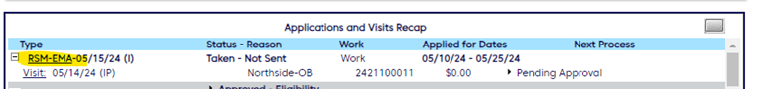 Go back to PACE, and click on the application name

1. Enter the information in the associated fields. Tracking Number is the ‘Case/Application’ number that begins with a T seen in the screen shot for step #15. Status should be changed to ‘Application Submitted’ from the drop-down selections, and ‘Sent to Agency Date’ will be the date you are submitting the application in Gateway.

1. Next, select the icon to add a NoteA close-up of a sign

   Description automatically generated
2. Using the information in GW under ‘Documents Pending Submission’ (seen in step 15), begin completing the note for PACE. Select Private, Role Type = HCR, Note Template type = Custom Notes. Then, use the format in the note below to standardize your notes, but Do not save your note yet.

*Ex: Submitted application in GW on 12.23.2024. 526 for account #2430101018. Tracking #T36137765. Uploaded tx#IESUC014733260.*

1. Go back to Gateway and click ‘Submit’ under the Documents Pending Submission section. Once the page re-loads, scroll to the bottom of the page.

1. A screenshot of a computer

   Description automatically generatedAt the bottom of the page under History of Documents Upload, you will see the Case Application Number and Transaction Number for the document uploaded. Copy and paste that number into the PACE note. Next, copy the note entered and then click ‘Save’

*Sample format for notes: Submitted application in GW on 12.23.2024. 526 for account #2430101018. Tracking #T36137765. Uploaded tx#IESUC014733260.*

1. Once the User note is crated and saved successfully, close out of the note window

1. Then, click Save in PACE on the Edit Application page

1. A screenshot of a computer

   Description automatically generated On the next page, select Person from the left menu, then you will see the application status has been successfully updated to ‘Pending-Application Submitted’

1. If the application type is RSM or Pregnant Woman, go to step 26. Otherwise, all updates have been made and there are no further steps.

1. For application types RSM or Pregnant Woman, there may be a baby linked to the application. You can identify that in the upper right corner in PACE. The baby will have a recent date of birth.

1. Click the baby’s name to navigate to the baby’s account in PACE

1. Follow steps 17 and 18 above, and in the Note, field paste the note you copied from the mom’s account in PACE, click Save, the close the window. Then, click Save in PACE on the Edit Application page (see step 23).

---DONE---

QUICK TIPS –

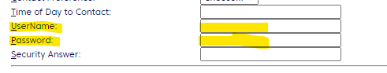#2 – If there is no Username or Password listed, use the format below to log into GW. If that format works, click ‘Edit’ under Person on the left menu, then add the User ID and Password, and click ‘Save’. Then, resume step #2 above.

a#6 – If this page loads, click “May Applications” which will then allow you to resume step #6.

